Eric Nagley  
2024-08-16  
Project 3

Corner Grocer History

The Corner Grocer History application is a console application that consumes the item purchase history report and can tabulate the data in three different ways. The options are 1, Look up an individual item; 2, Output all items and their counts; and 3, Output all items as a histogram. The application will consume the item history report on the first run and build a backup file of the tabulated counts.

## Main Menu

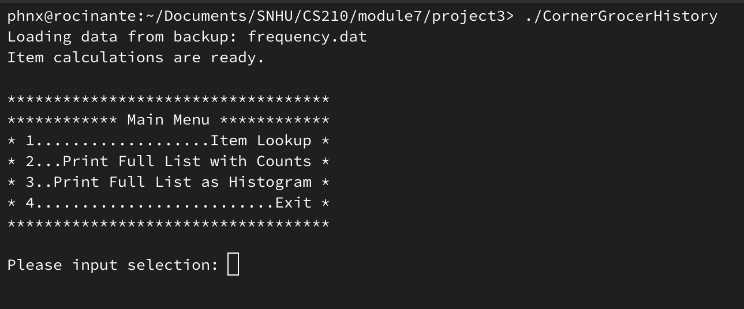

The main menu lists the available options and asks the user for their selection. On an invalid selection, the user is warned, and the menu will be output again. For selections 1 - 3, the application will return to the main menu after outputting the requested response. Option 4 will exit the application.

## Option 1 - Item Lookup

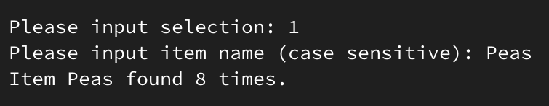

Option 1 will prompt the user for the item to look up. This option is case-sensitive. If the item is found, it will return the above output with the item and its count.

## Option 2 - Print Full List with Counts

Option 2 will output the full list of items and their counts. The items are in alphabetical order.

## Option 3 - Output Full List as Histogram

Option 3 will output the alphabetical list of items and represent the counts as a histogram.

## Option 4 - Exit

This option will exit the application.